[Systems and Network Programming](https://courseweb.sliit.lk/course/view.php?id=3166)

Cve 2019-14287

Sudo byepass

IT19157619

R.M.S.S. Rathnayake

INRODUCTION

sudo stood for “super user do” and it’s a program for unix like operating systems that help user to run the programs with security privileges from another user and this is commonly expanded as “substitute user do” but it is still called super user do. After sudo code user must enter their password for authentication.

In1980 Robert Coggeshall and cliff spencer wrote the subsystem.

Since 1994 current version publicly maintained by Todd C Miller. Latest sudo stable release is SUDO 1.9.0 on 11th April 2020. CVE 2019-14287 vulnerability can be founded in SUDO versions before 1.8.28 .This vulnerability allows bypass of user restrictions. This vulnerability give the ability to execute commands as the root. Root is the default username that has access to all commands and files on linux an unix-like OS.

On 14th 0ctomber 2019 sudo team informed about this CVE-2019-14287 vulnerability and this was discovered by joe vennix who works in Apple information security. This CVE-2019-14287 vulnerability take 8.8 CVSS version 3.x score ,so this is a high severity vulnerability. And this vulnerability is easy to exploit.

Invoking sudo with -1 or -4294947295 and after that any user can run command as the root. This can be done by giving ALL permissions to another user in sudoers file.

Exploitation can be done in same computer using terminal.

This vulnerability is effected only sudo versions before 1.8.28. used ubuntu linux os in virtual box.

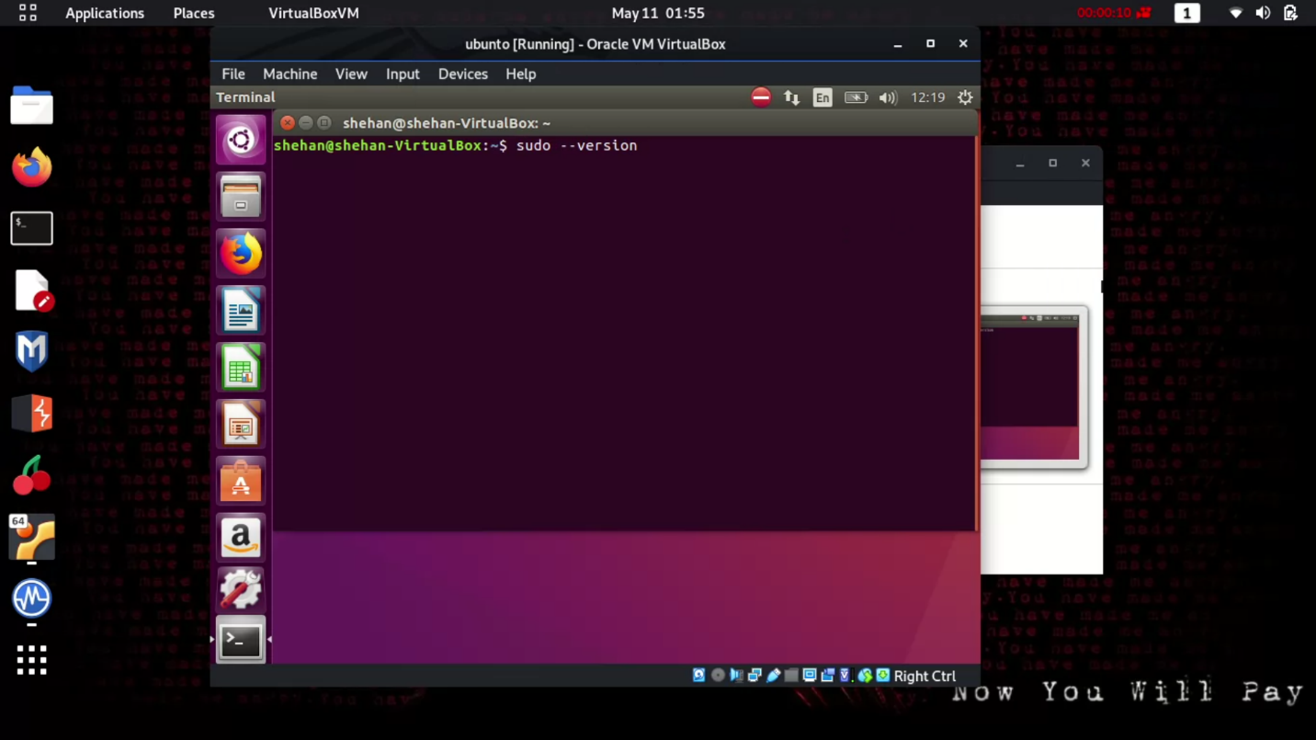

1. Using bellow command we can check our sudo version.

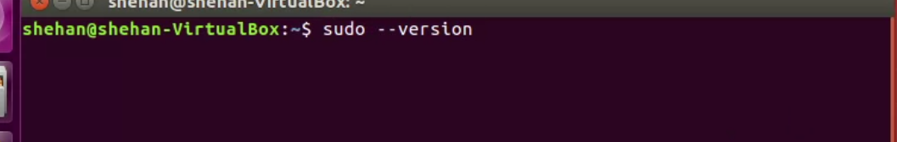

This is a ubuntu linux os that has SUDO 1.8.16, so this is a older version than 1.8.28 so this version is still vulnerable to CVE-2019-14287 vulnerability.

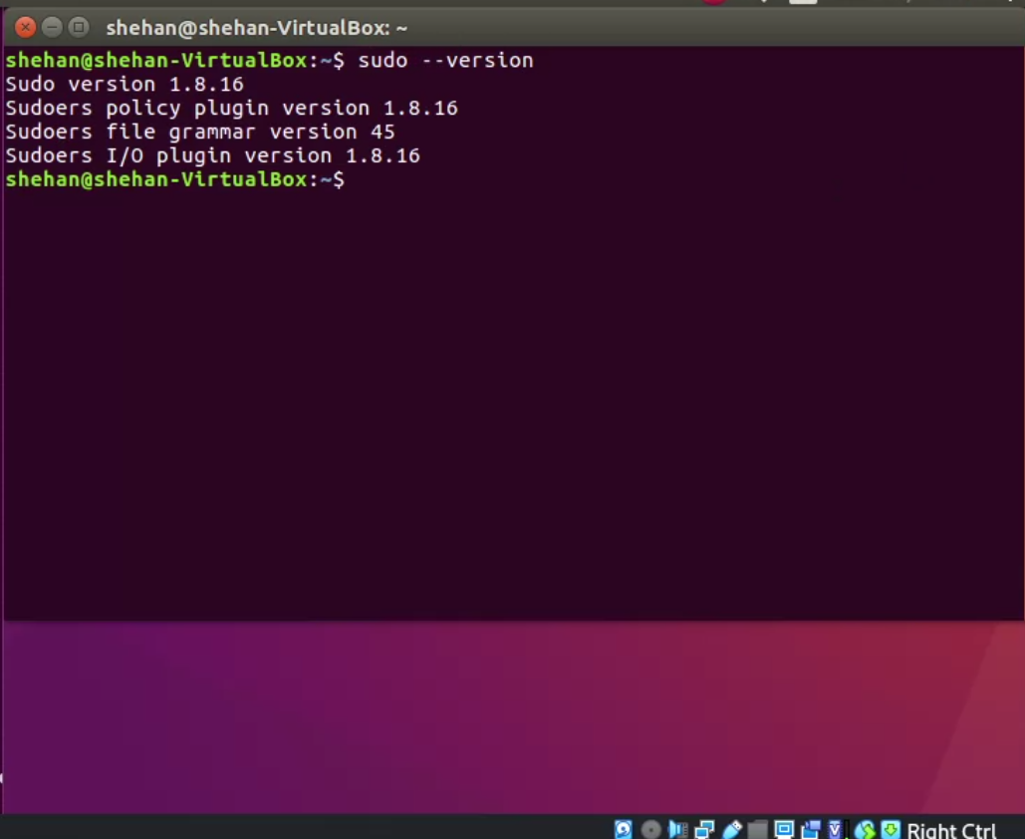

1. Information about the users are stored in passwd file.so we can check passwd file using this command

Cat /etc/passwd

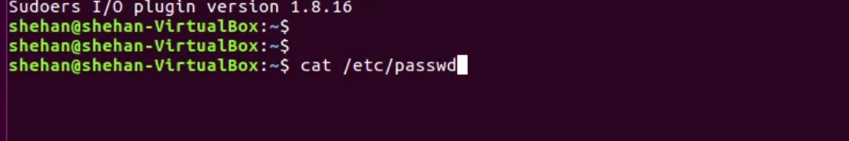

This command shows bellow results.

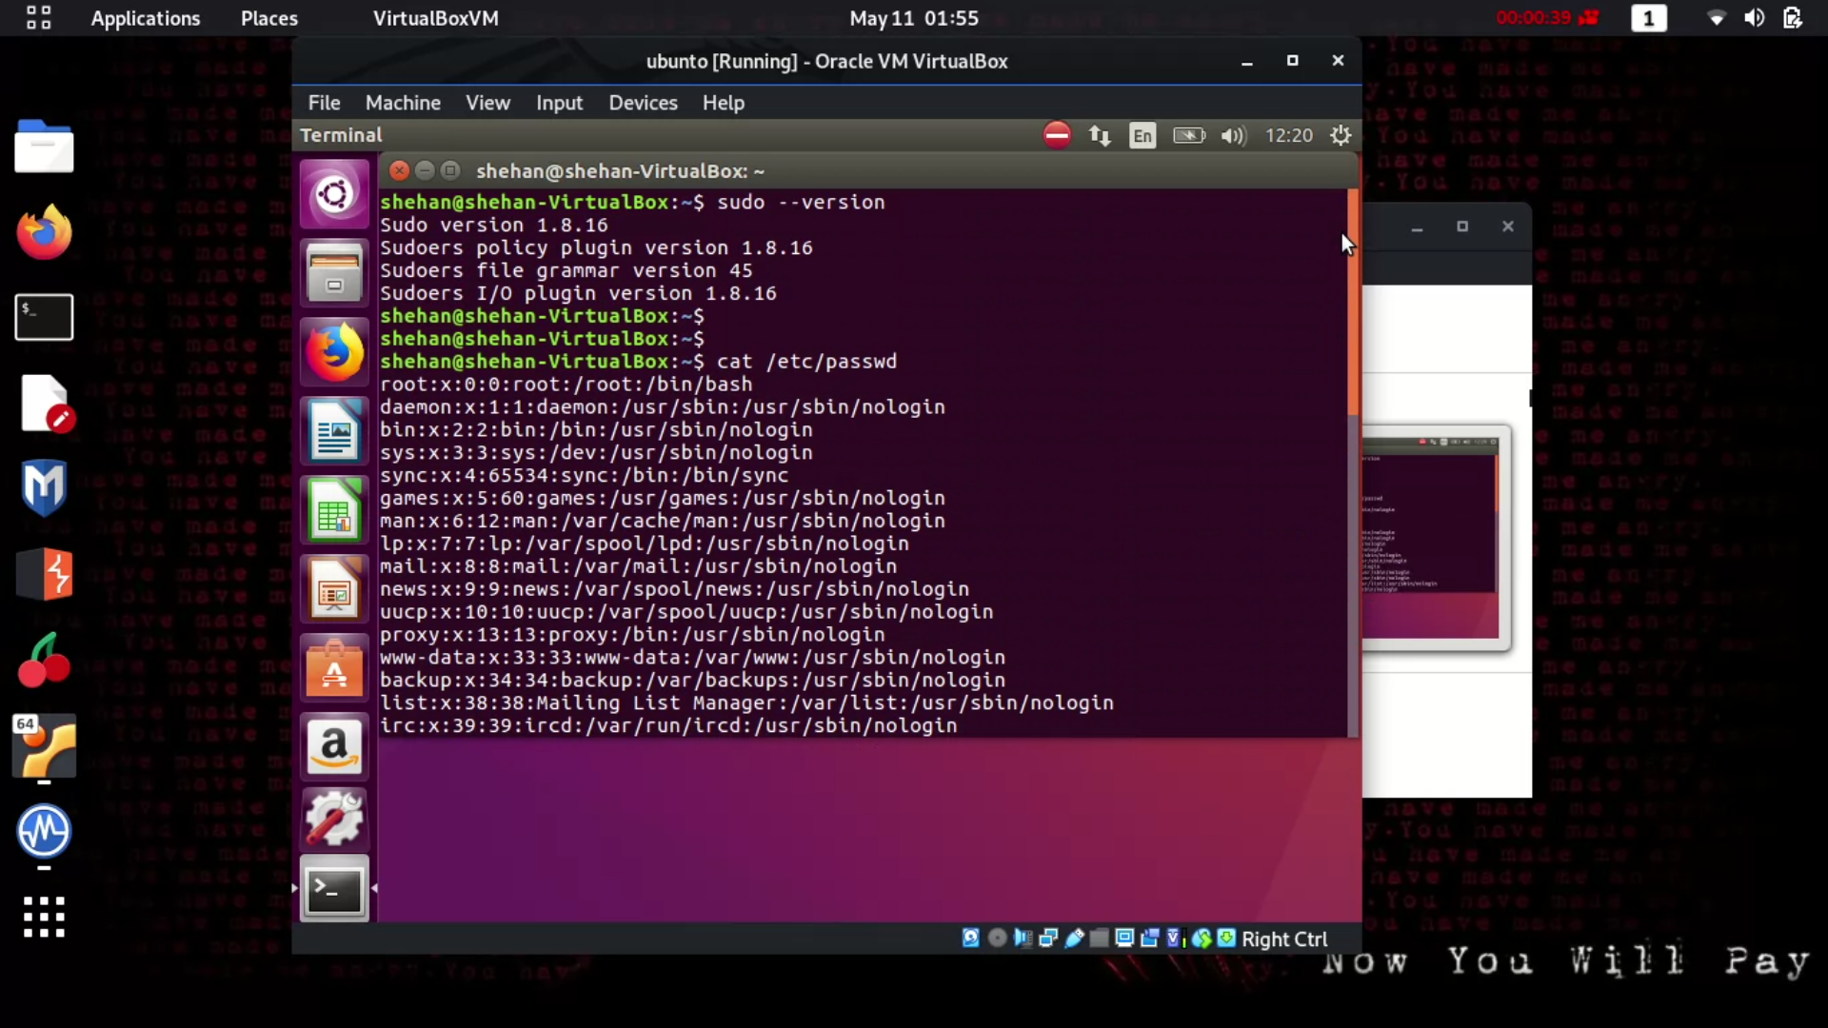

First raw root is the user name and passwords are all denoted by x and next is root id for the root account user id is always 0 next is group id it is also 0 and next is home directry and finaly the shell that root loged in (/bin/bash) . And password is x means passwords are encrypted. This passwd file can be access by any user so passwords are encrypted but shadow file which only can access by root user.

After the root account there are systems accounts daemon, bin, sys, and more these accounts also have password that denoted by x, account id , group id.

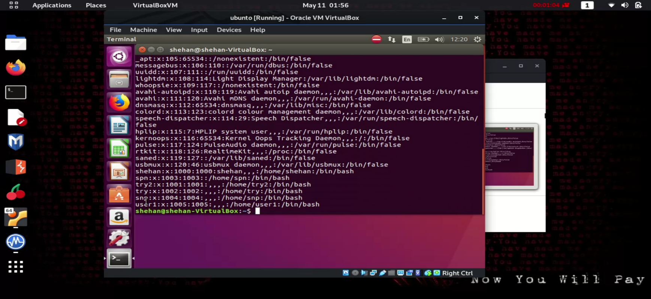

At the end there is 6 users and there user id s are 1000 or greater than 1000.

1. Next create a user by following command

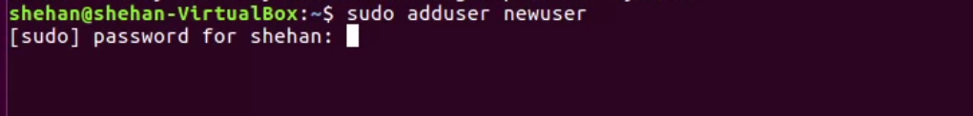

After executing this command it ask password for shehan.after entering it

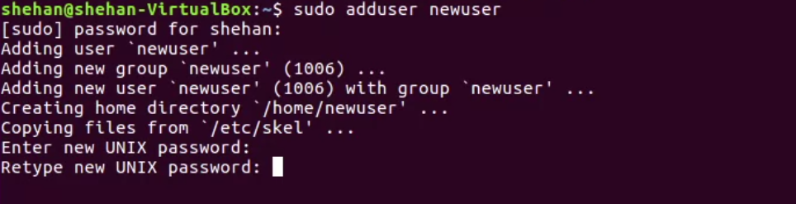

It ask new password and again retype it for confirmation.

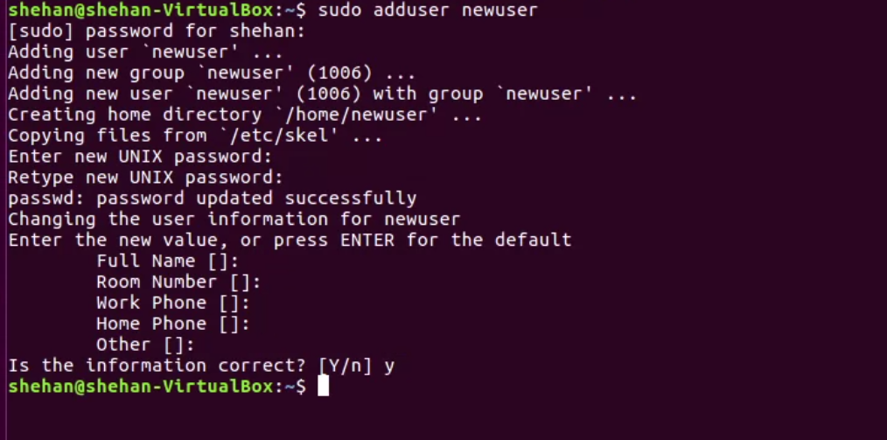

After confirming the password newuser need to enter informations,but we can let that fields empty and give y for the confirmation. then it saves the information.

1. Next we need to set permissions for created newuser. For that we need to execute

Sudo visudo

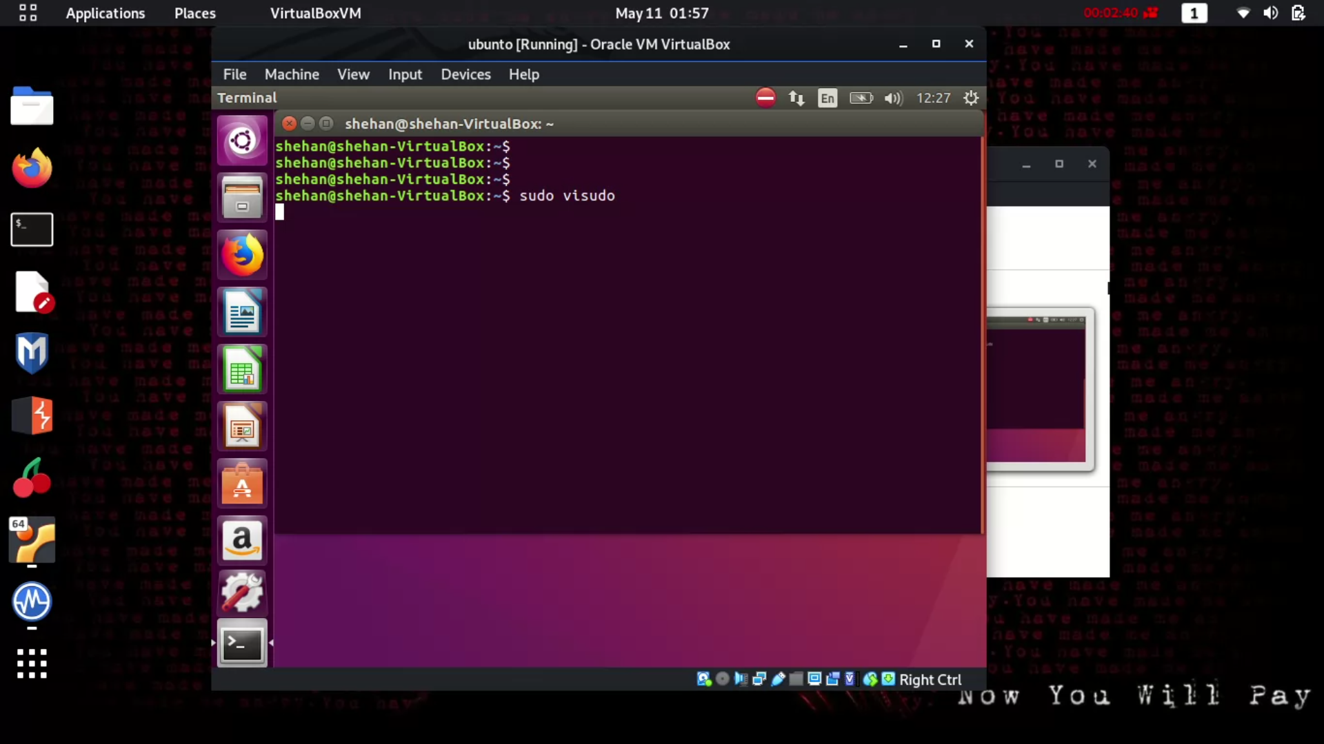

Visudo command is the safe way to edit /etc/sudoers permissions. This command open following file

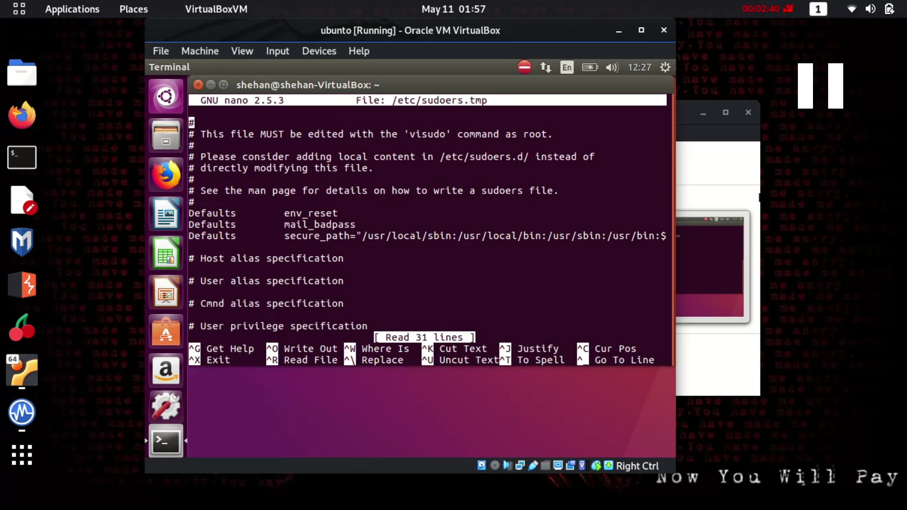

We can specify host alias, user alias, command alias but we need to specify user privileges here

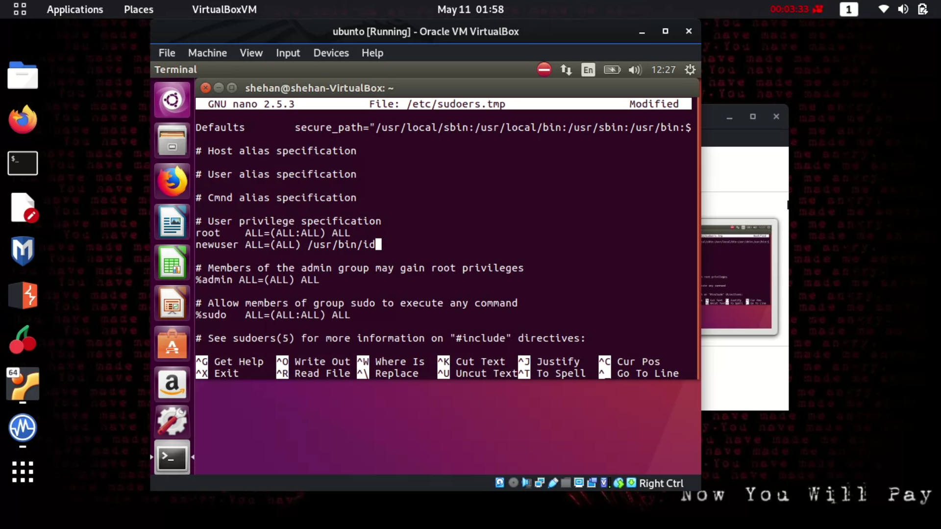

We can change it as above adding newuser privileges.

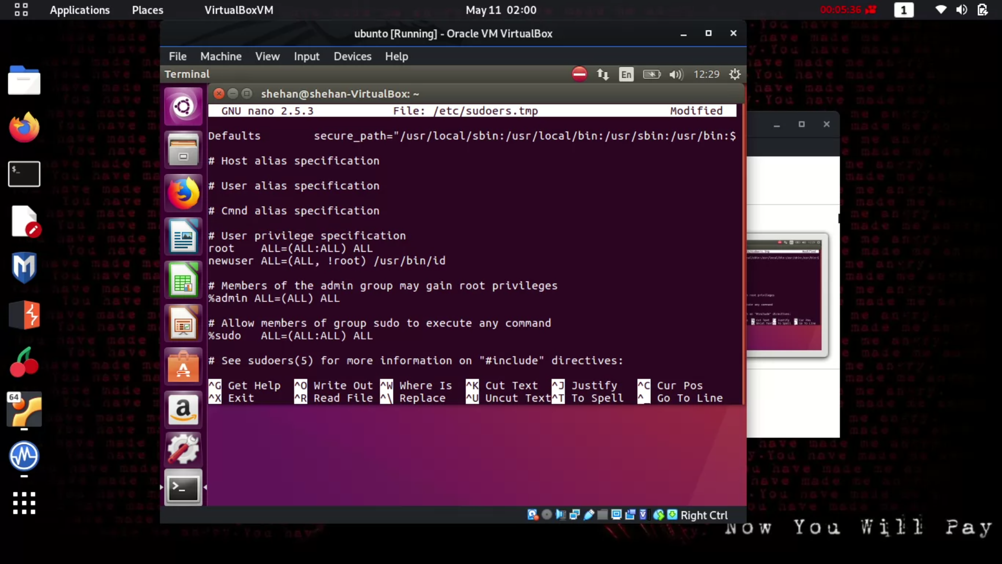

Root ALL=(ALL:ALL) ALL

This means root user can execute from all hosts as all users, all groups and can run all commands

in newuser =(ALL, !root) /usr/bin/id commands means this means anyone except this user can run id command.

Edit as this and need to save the changes

1. next we need to switch the user using su newuser

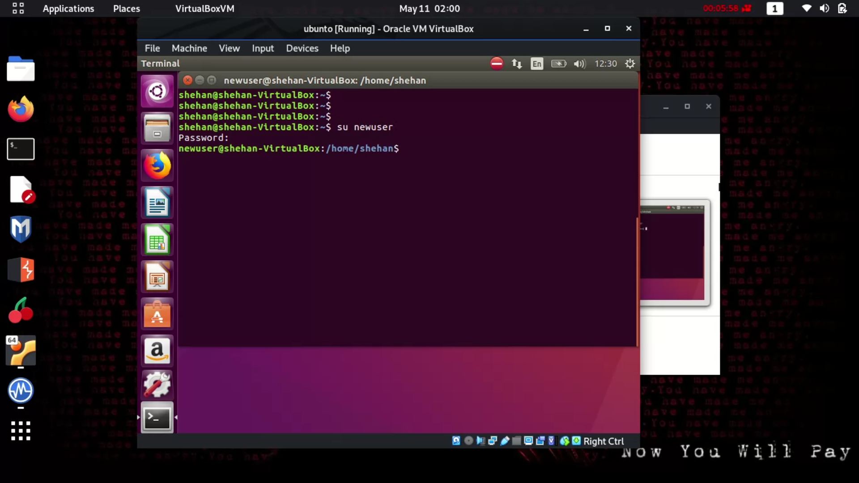

And we need to enter the password we gave when creating this user.

6.

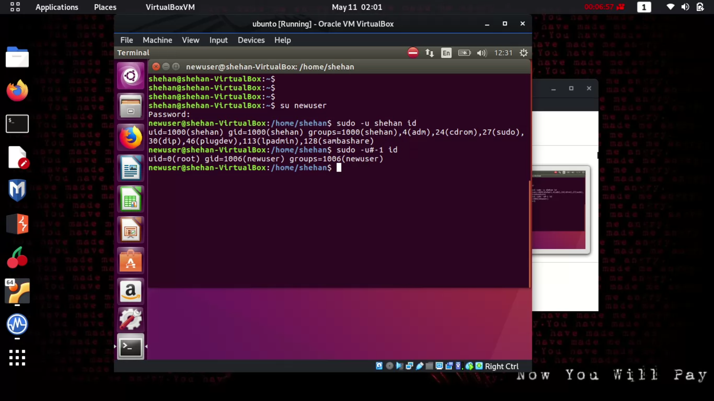

Run sudo -u shehan id command and it gives the id details about user shehan.

But when we give invalid number like -1 it also show the id details of the user.

when giving the parameter user id “-1” or its unsigned number “4294967295”, the command will run as root, bypassing the security policy entry we set in the example above.

7 .if we give more access to the newuser it will work as root

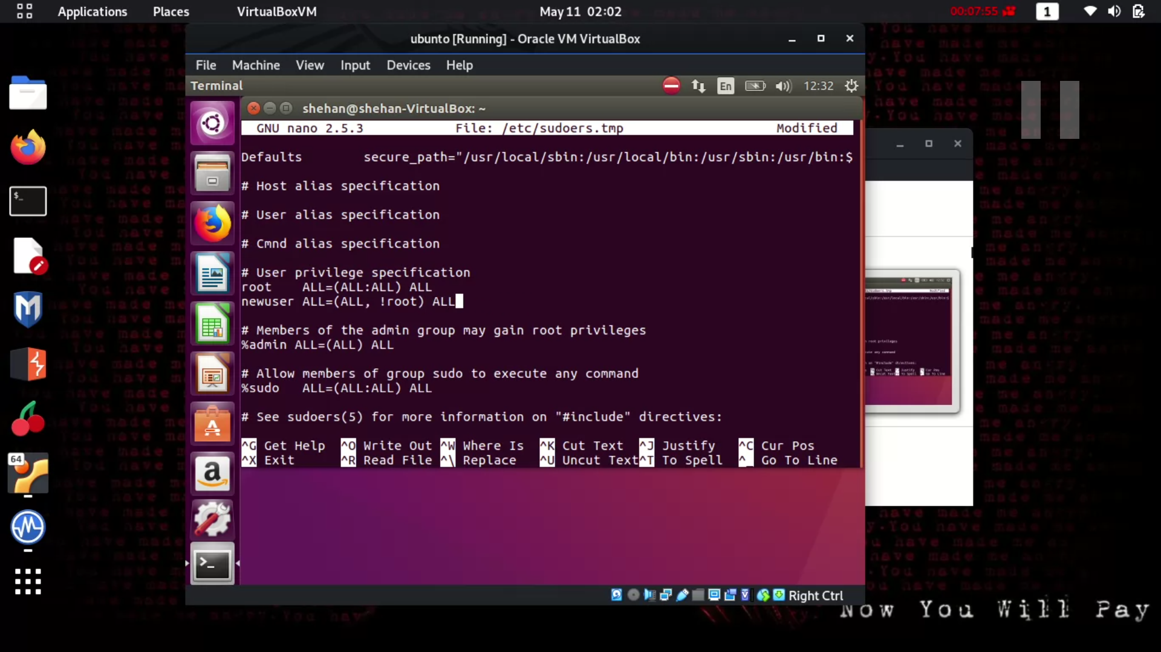

Change newuser privileges in to in newuser =(ALL, !root) ALL and save and exit. This give all privileges that root has. After this again switching to the new user.

And run sudo -u#-1 /bin/bash command and this time it will execute and as the bellow picture newuser change in to the root user and , using whoami command can clarify the user name.

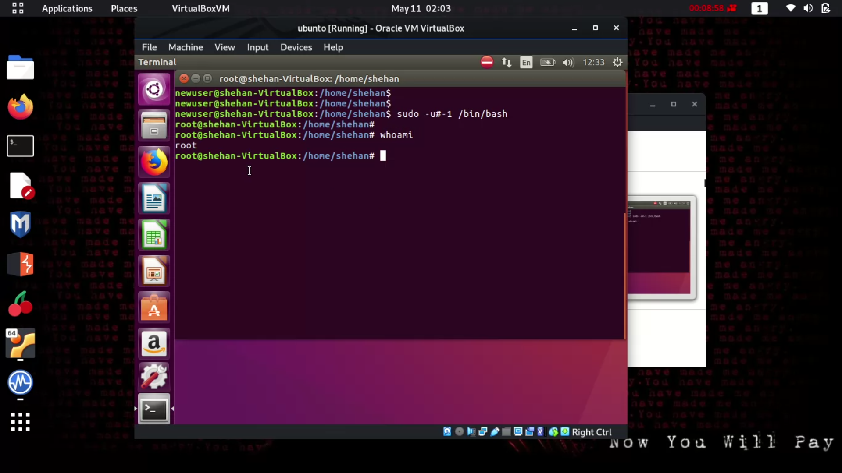

Now newuser has the all access to the root has it means newuser can use every command and has access to the everything in that system.

Conclusion

This vulnerability give the root access to the every user in linux machine.

This 8.8 CVSS version 3.x score taking vulnerability is can do serious damages to the linux systems and sudo allows users to run commands with other user privileges.updating sudo version is the solution for this. This vulnerability is fixed from Sudo version 1.8.28.